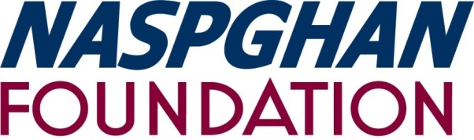

The NASPGHAN Foundation for Children’s Digestive Health and Nutrition introduces
Digestive Health for Life Partners Program

Partners Program Application

October 1, 2019- September 30, 2020

2019-2020 Membership Year

Member Categories:

Silver: $5,000 ________ Gold: $10,000 ________ Platinum: $20,000 _______

Company

Contact Person Title

Address

City State Zip

Phone

Email

Authorized Representative Title

Signature Date

Make checks payable to: NASPGHAN Foundation

Send completed application and payment to:
714 N. Bethlehem Pike #300
Ambler, PA 19002
Attn: Partners Program

For more information please contact:
Monique Taylor
215-641-9800
mtaylor@naspghan.org

