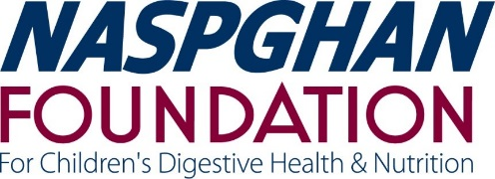

NASPGHAN FOUNDATION
ADVANCED FELLOWSHIP TRAINING IN PEDIATRIC ENDOSCOPY
Submission Deadline: August 23, 2021

The award is expected to begin on July 1st of each academic term although alternate start dates will be considered to accommodate non-traditional academic schedules.

DESCRIPTION AND OBJECTIVE
The ever-increasing complexity of pediatric patients with gastrointestinal, liver and/or pancreatic problems has created a need for pediatric gastroenterologists who are skilled in advanced endoscopic procedures. These skills are difficult to acquire in the course of routine pediatric GI Fellowship training experiences. To address this growing need and to provide a pathway for training of pediatric experts, the NASPGHAN Foundation desires to develop an advanced fellowship in pediatric endoscopy.

The NASPGHAN Foundation Advanced Fellowship in Pediatric Endoscopy will provide up to $75,000 in direct funding to support one year of advanced training in pediatric endoscopy for a member of NASPGHAN in good standing. Applicants are expected to identify a mentor and a host endoscopy program prior to application for funding. The fellowship must include a well-defined clinical experience as well as a focused research and/or quality improvement project. Examples of areas for training include but are not limited to: Endoscopic retrograde cholangiopancreatography (ERCP) with stenting and/or sphincterotomy, endoscopic ultrasound (EUS), advanced approaches to control GI bleeding (sclerotherapy, argon laser, clips, etc), transnasal endoscopy, peroral endoscopic myotomy (POEM), esophageal or intestinal stricture dilatation, pancreatic pseudocyst drainage, etc.

The primary objective of the fellowship is to catalyze and increase the number of highly-trained, expert endoscopists clinicians and educators among the membership of NASPGHAN, as a means to improve service to our patients and the public.

ELIGIBILITY
- The applicant must be a MD, DO and a member in good standing of the North American Society for Pediatric Gastroenterology, Hepatology and Nutrition.
- Applications will be accepted from candidates who are within ten years of their GI fellowship training.
- We encourage the creation of innovative or multidisciplinary training opportunities in addition to those structured in a traditional medical school and academic university hospital setting.
- Fellowships may be conducted in a variety of settings, including hospital-based programs, university endoscopy programs, government programs, or not-for-profit entities.
- The applicant may not hold salary funding from any other granting agency for the award period.
- Although not required, strong preference will be given to applicants seeking training at a location distinct from the institution in which their fellowship training occurred.

GRANT TERM AND STIPULATIONS
- The total award is up to $75,000.00 in direct funding support for one year.
- Institutional indirect costs are not allowed.
- The award should be used to support salary up to $75,000 (base salary plus fringe benefits). An additional $3,000 discretionary account may be established from the award and is designated specifically for travel, books, journals, and other discretionary expenses.
- All publications resulting from work supported by the NASPGHAN Foundation Advanced Fellowship in Pediatric Endoscopy must acknowledge support by the grant
- A financial statement and progress reports are required as a close-out report at the end of the training interval. The nature of the program requires Olympus to report transfers of value to individual program fellowship recipients and/or healthcare teaching institutions affiliated with the program. As such, recipients agree to provide Olympus with the required and necessary data and information for Olympus to fulfill its obligations under applicable governing laws and Olympus transparency reporting policies in accordance with a specific timeline. It should be completed on or before July 31, 2023 and should provide Olympus with a report, in reasonable detail, outlining the program results including any white papers, research protocols or other appropriate communications or collateral accounting for expenditure of the grant funds. Upon Olympus’ request, the recipient will participate in a conference call or WebEx with the Olympus Grants Committee to provide a summary of the grant recipient’s program.
- Three interim reports are required. All must submitted on a reporting template that will be made available to your grant department office.
- The awardee must attend the NASPGHAN 2021 Annual Meeting to accept the award. The awardee is expected to make a presentation at the 2023 NASPGHAN Annual Meeting.

REVIEW PROCEDURES

- The NASPGHAN Endoscopy Committee and invited experts in the field will review and rank applications based on strength of the applicant and the strength of the proposed training program. This scoring system uses a 9-point scale for the overall impact score and individual scores for (at least) five scored criteria (significance, innovation, approach, investigators, and environment). Members of the “study section” will meet face to face to discuss the grant applications in an NIH modelled review section.

- The ideal applicant will be the individual who meets the objective of the fellowship, demonstrates a proclivity for and track record of interest in pediatric endoscopy, along with an enthusiasm for a continuing career contributing to the field of pediatric endoscopy.

- Although not required, strong preference will be given to applicants seeking training at a location distinct from the institution in which their fellowship training occurred.

Members of the review panel will follow strict conflict of interest guidelines. Contact between the applicant or sponsors with committee members regarding applications is strictly prohibited and may lead to disqualification from further consideration.

NASPGHAN FOUNDATION
ADVANCED FELLOWSHIP TRAINING IN PEDIATRIC ENDOSCOPY

INSTRUCTIONS

FAILURE TO ADHERE STRICTLY TO THESE GUIDELINES COULD RESULT IN THE DISQUALIFICATION OF YOUR APPLICATION

All applications should be completed on line through the NASPGHAN Foundation Grant Portal: https://naspghan.secure-platform.com/a/organizations/main/home

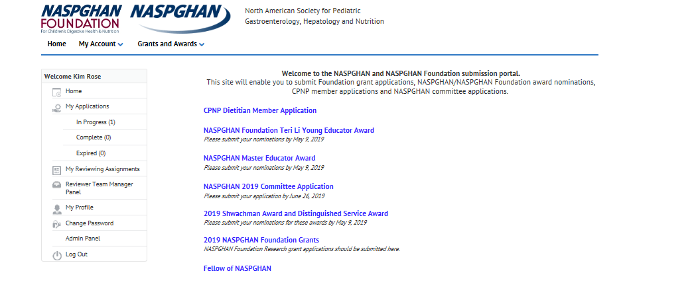

Completed applications must include the following.
  - NIH biographical sketches of the principal investigator and sponsors. NIH biosketch format and instructions are posted at https://grants.nih.gov/grants/forms/biosketch.htm.

  - A training and career plan up to 5 pages as outlined below with 1/2-inch margins. Times New Roman or Arial font no less than 11 point are required. Page limitations and style requirements are strictly enforced. (No application more than FIVE single spaced pages will be reviewed).

    - Applicant personal statement outlining interest in a career as an advanced endoscopist (approximately 1 page)

    - Structure of the proposed clinical, research and programmatic experience. This section should include: a portrayal of goals for the training year; a statement of the clinical underpinnings of the training experience; role of the mentor/mentorship team, and a formal mentored research proposal (achievable within the one-year time frame of funding). The candidate is encouraged to use creative latitude in structuring this portion of the proposal to permit and describe a rich training experience. We encourage partnerships between adult and pediatric endoscopy units.

    - Description of the environment and previous involvement of the institution and mentorship team in endoscopy training.
    - Long-term career plans in advanced endoscopy and how the proposed experience will facilitate achievement of these plans should be briefly described.

  - Two letters of nomination are required;
- One from the applicant’s program director or division chief
- The second from the applicant’s proposed mentor
These letters should clearly outline the applicant’s track record to date and the candidate’s aptitude and zeal for a career in endoscopy. The mentor’s letter should express their support and commitment to the proposed training program.

  - A one-year budget must be accompanied by a justification of the salary and must be appropriate for the institution’s salary structure for the candidate’s position (fellow, faculty member, etc.). A $3000 non-salary line item in a separate item for discretionary expenses like travel, supplies, is permissible.

